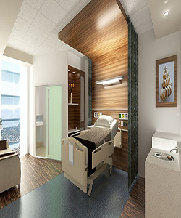

Durian Hospital bed

$235.29

Availability: In stock

**Description:**

Majestic electric hospital bed with 2 columns shored up raising system. Developed to meet the highest hospital-related standards Electric bed with column system. Max load: 230 kg Base made up of four separate ABS modules. Built-in bed extension (+15 cm). Remote control. Nurse control panel. Safety GO button. Auto contour (11 cm back / 7 cm pelvis) Rechargeable long-life battery. Protective bumpers. ABS fairing. Four supports for IV pole and trapeze bar. Cable winder support. Mattress stops. Central braking system. Multi-directional wheel. Back angle indicator and Trendelenburg/Reverse Trendelenburg. Bilateral accessory holder.